**System Design : Instagram**

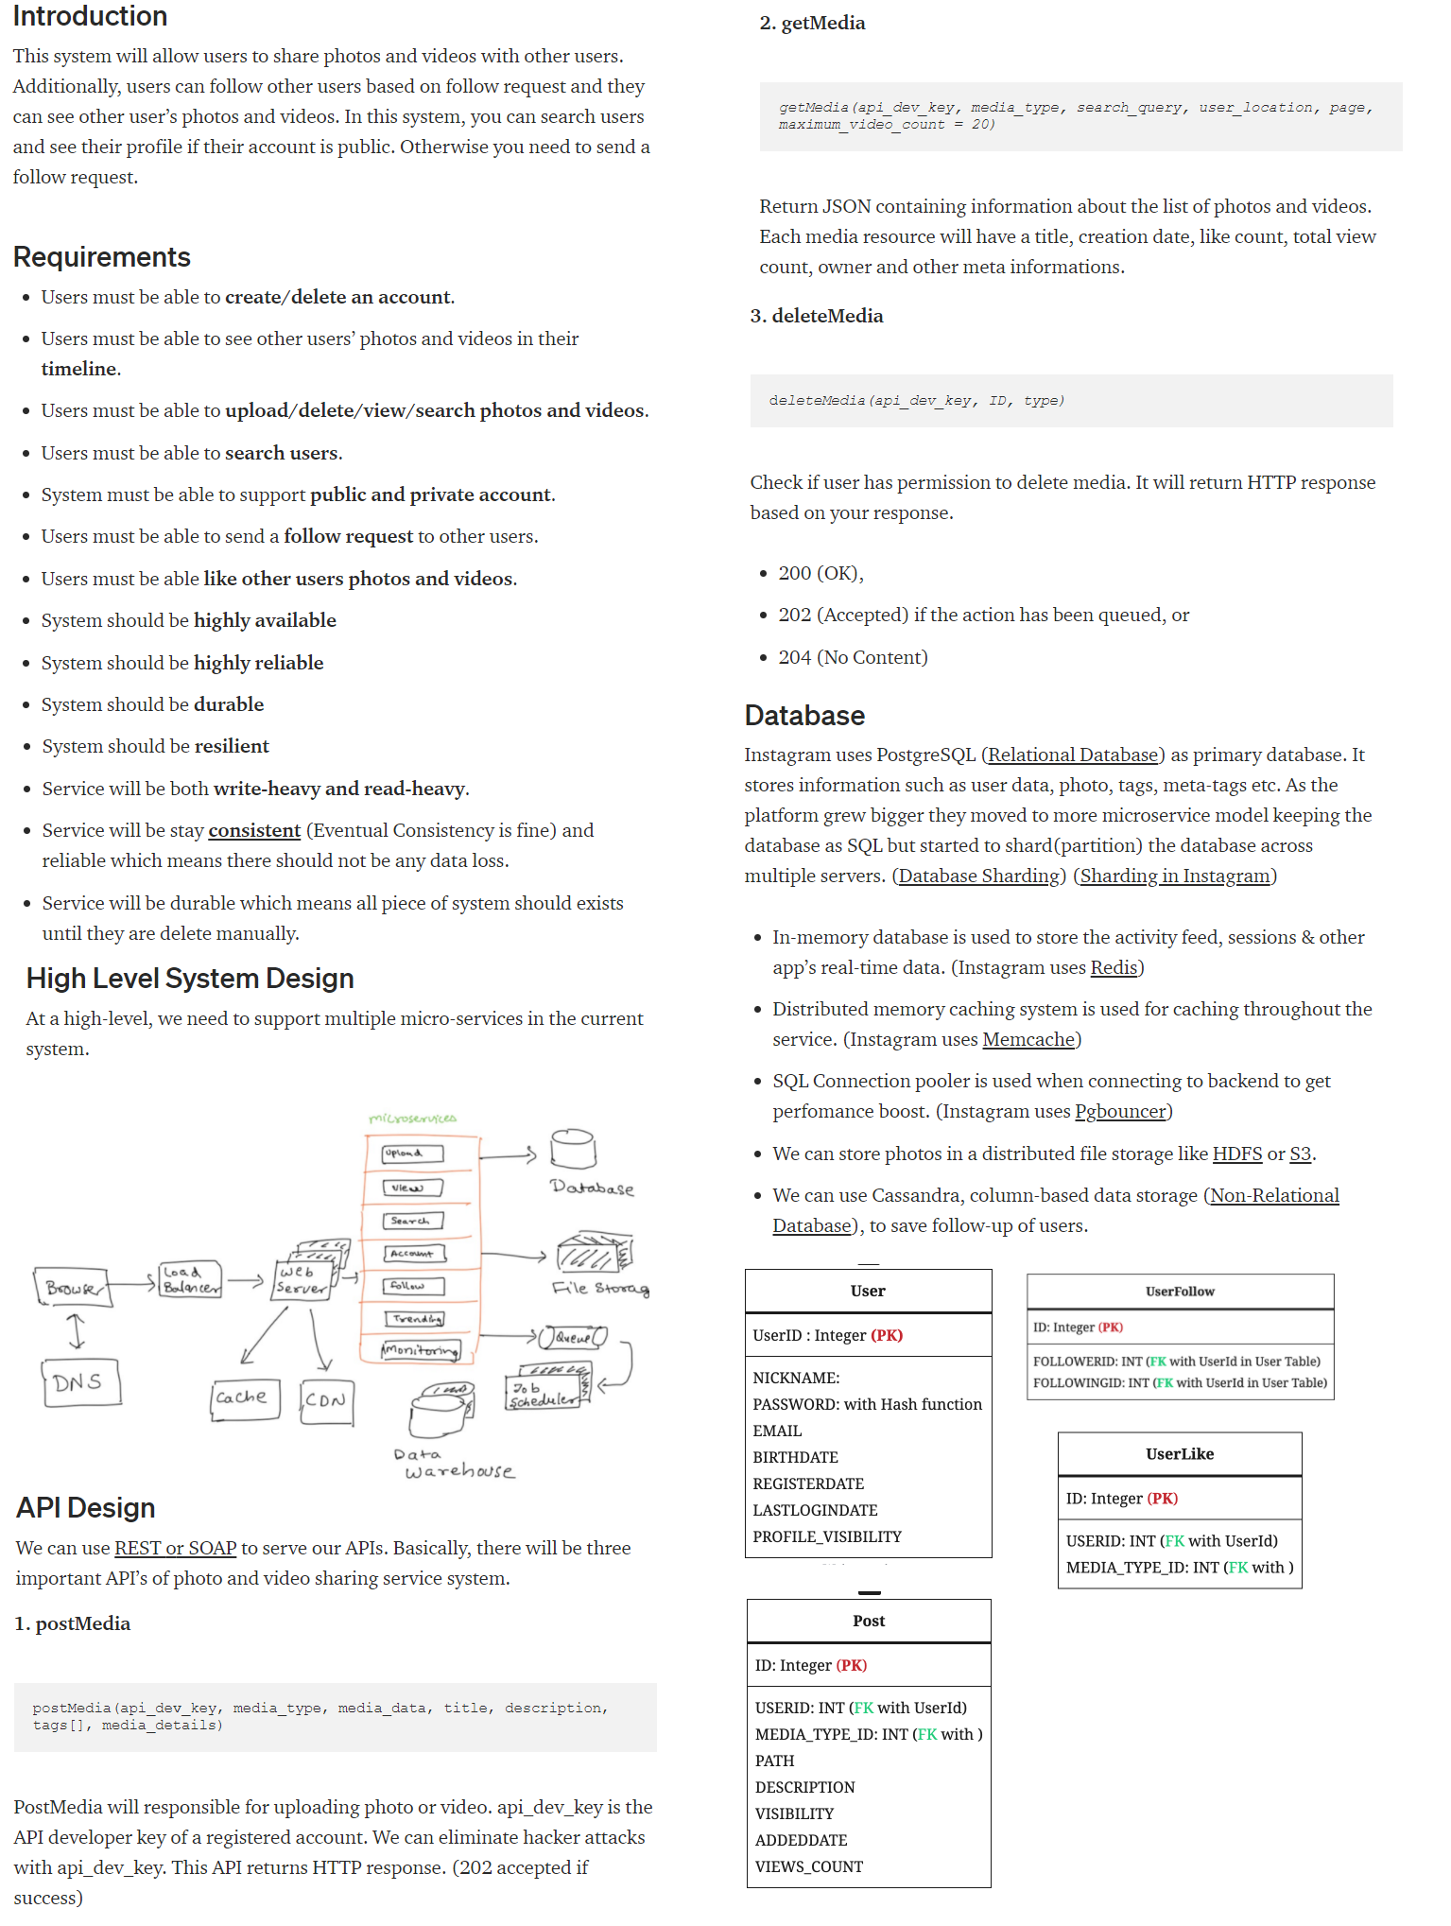

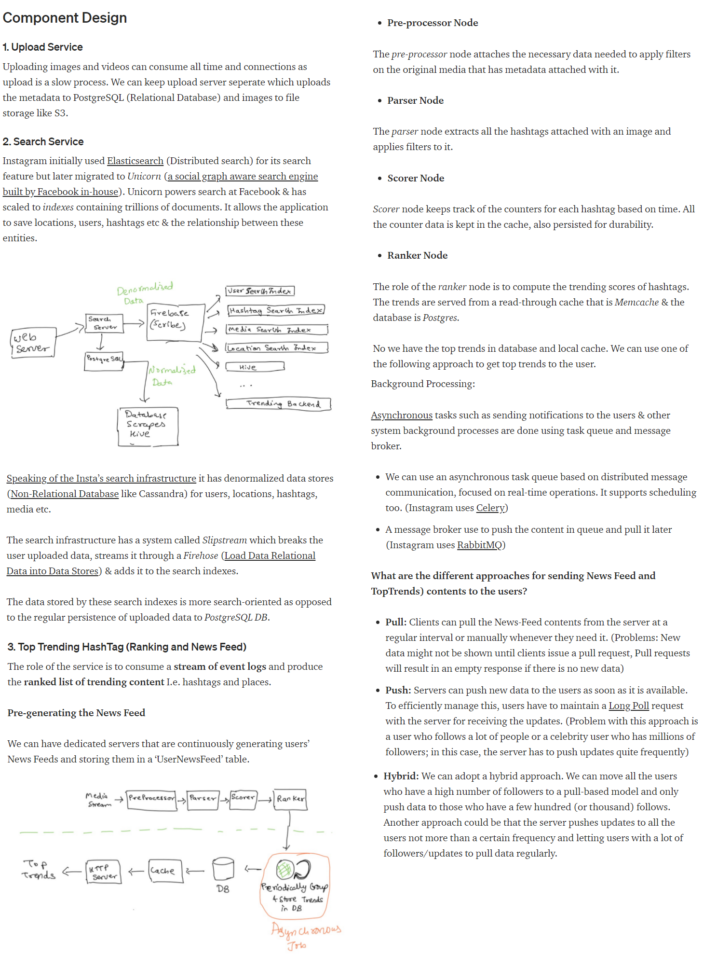

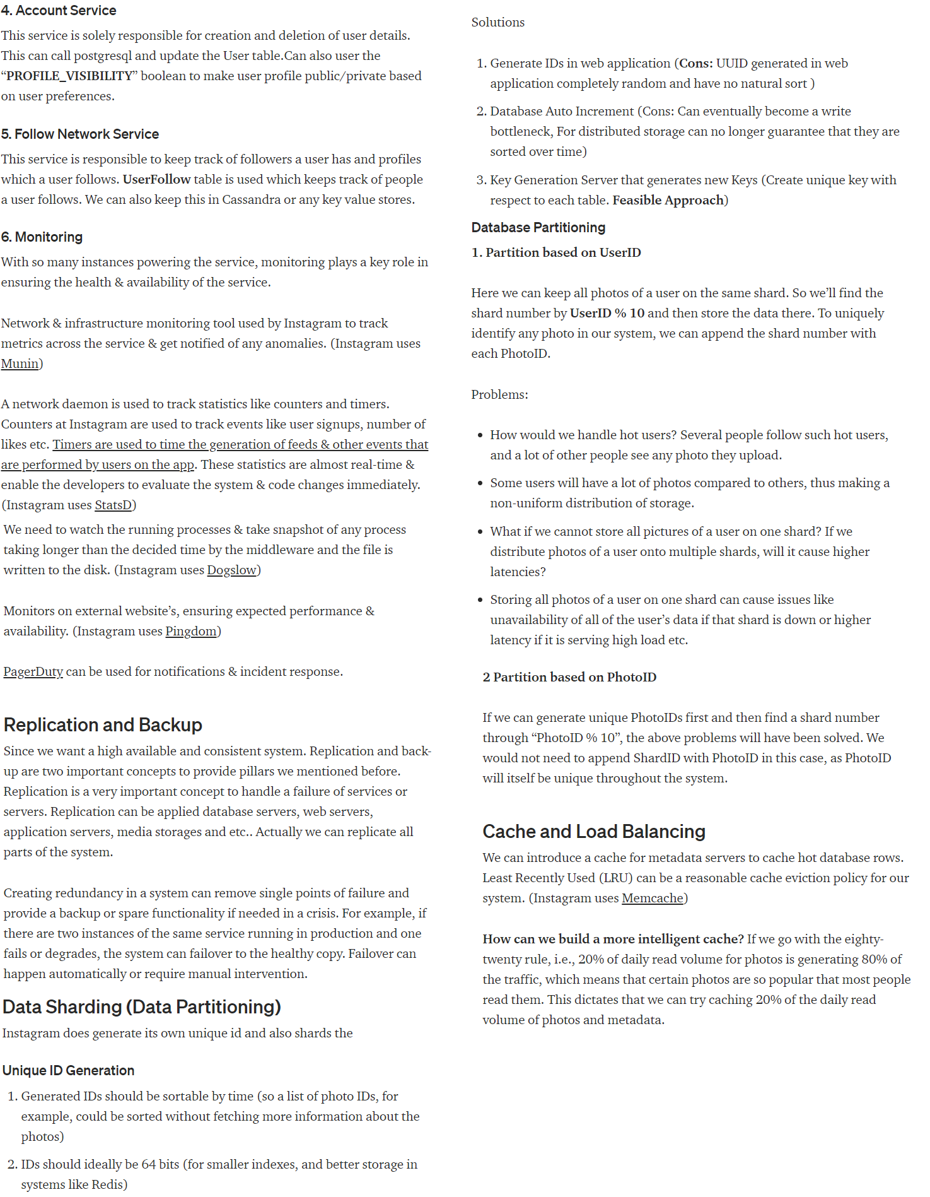

# System Design: WhatsApp

# 

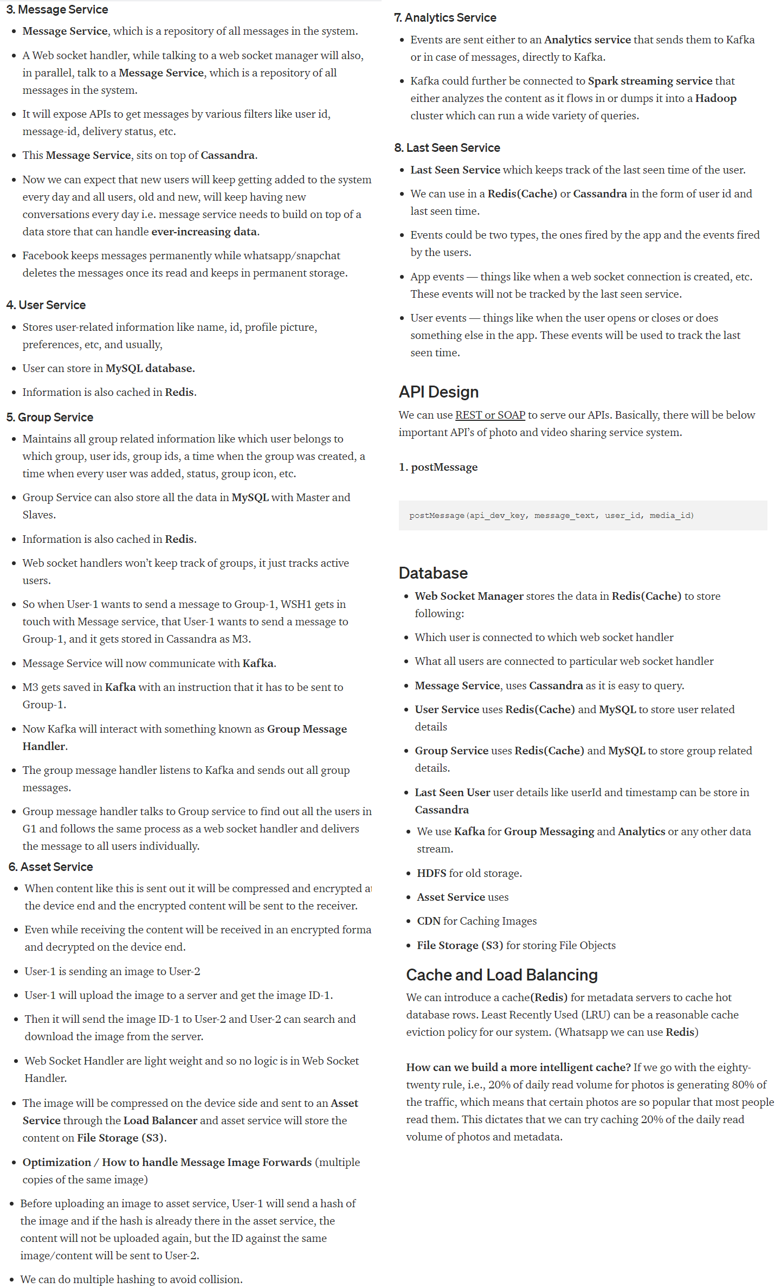

# System Design: AutoComplete System

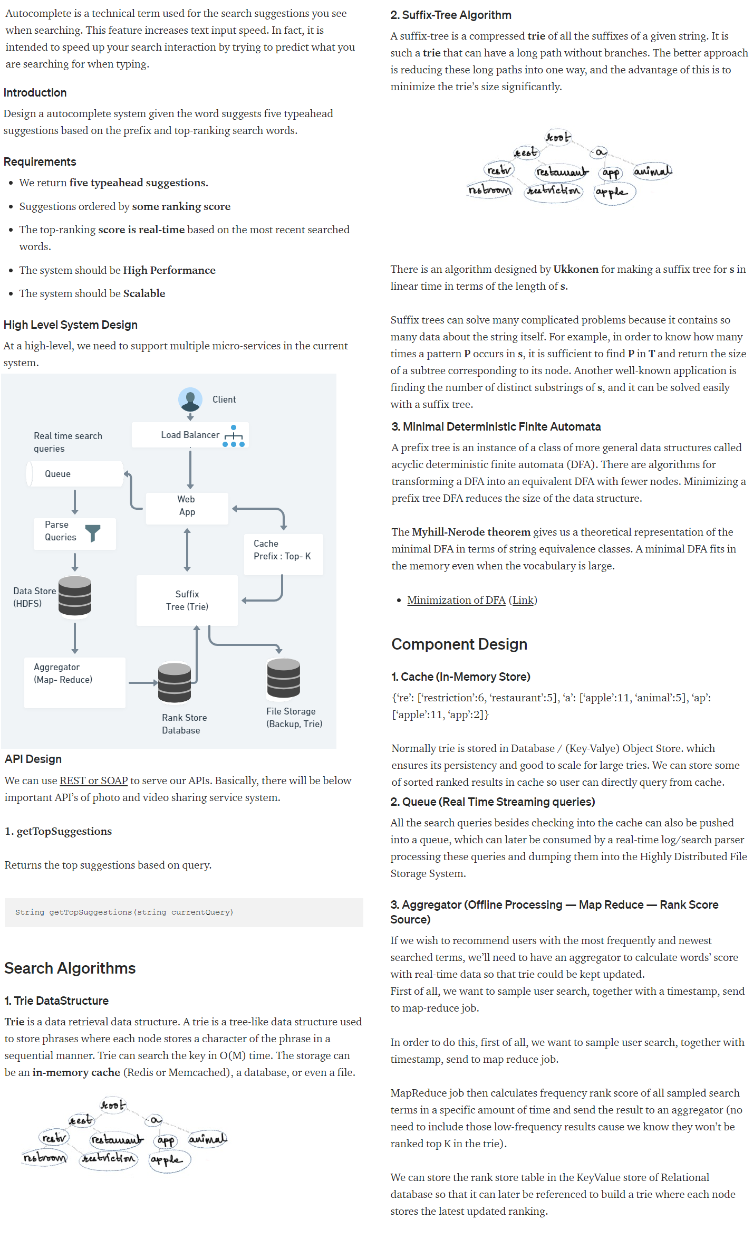

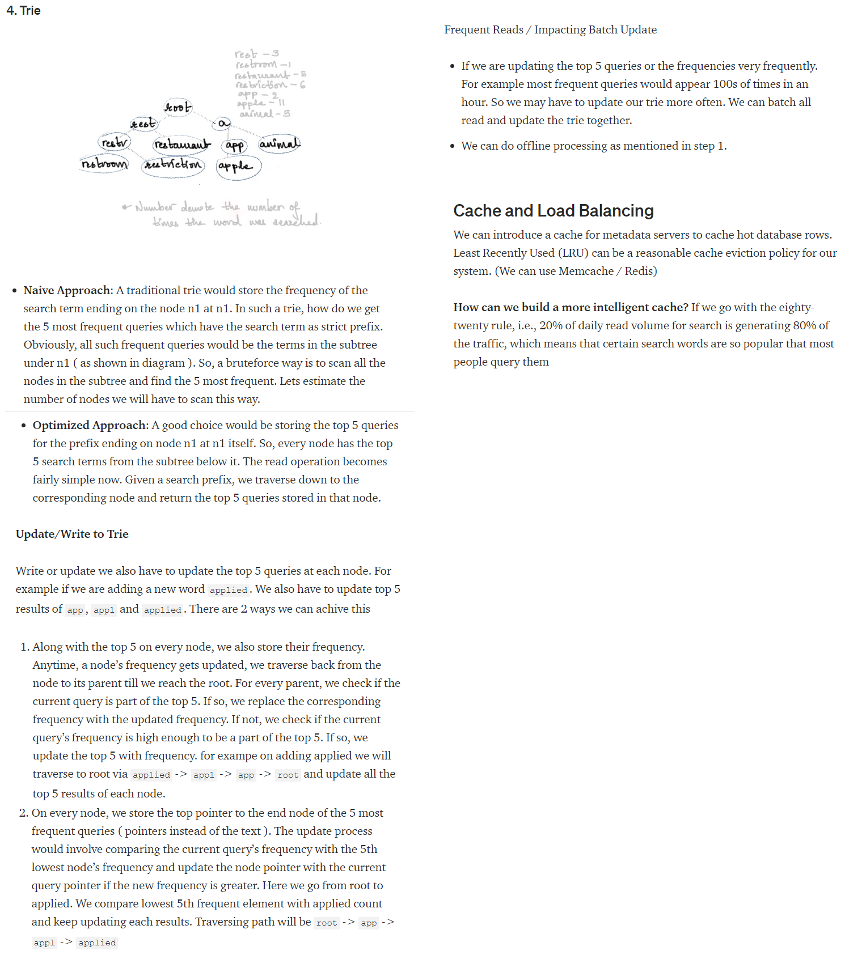

# System Design: Kubernetes

# 

# 

# System Design: Web Crawler

# 

# 

# System Design: Twitter

# 

# 

# 